Inventory product management
Ideation Phase
Empathize & Discover

Date | 07/03/26
Team ID | SWTID-2026-5992
Project Name | Product Inventory Management System
Maximum Marks | 4 Marks
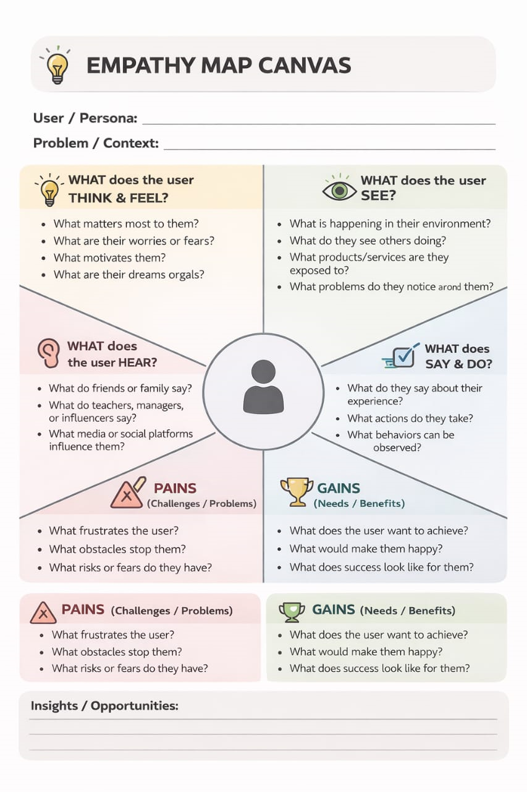

Product Inventory Management System – Ideation Phase

Phase: Empathize & Discover
Goal: Understand the needs, pain points, and behaviors of small business owners or users managing inventory.

User Personal (Center)
- Role: Small Business Owner / Inventory Manager
- Age / Demographics: 25–45, tech-savvy or semi-tech-savvy
- Motivation: Keep track of products, avoid stock-outs, save time

Empathy Map Quadrants
Quadrant | Questions to Explore | Examples / Prompts
SAYS | What does the user say about inventory? | “I need a simple way to check stock.”  “Existing software is too complicated.”
THINKS | What is the user thinking but might not say? | “I hope I don’t run out of my best-selling items.”  “I wish it didn’t take so much time to update stock.”
DOES | What actions do they take currently? | Manually updates Excel sheets, counts stock daily, uses multiple apps.
FEELS | What emotions do they experience? | Frustrated, anxious about running out of stock, overwhelmed by complex tools.

Pains / Challenges
- Current inventory management tools are complicated or expensive.
- Manual tracking leads to errors and time wastage.
- Difficult to predict stock needs.
- Lack of integration with sales and suppliers.

Gains / Goals
- Simple, intuitive interface for easy stock management.
- Real-time stock tracking and alerts.
- Ability to analyze trends and predict future stock needs.
- Integration with sales channels and suppliers.

